Bodhi Technology Lab

Bodhi Technology Lab – Awaken Technology for the Dharma‑Ending Age

Awaken Technology for the Dharma‑Ending Age
In the time of “Digital Tam,” meditation is often treated as a commodity. Over 275 million people worldwide practised meditation in 2025 missiongraduatenm.org, and the wellness app market generated about $1.4 billion in revenue in 2023, with projections exceeding $7 billion by 2033 missiongraduatenm.orgmissiongraduatenm.org. Yet the true Way can become diluted in a sea of commercialised apps, and women are almost twice as likely to meditate as menmissiongraduatenm.org—underscoring both the popularity and the risk of superficiality. Bodhi AI Lab is not here to build “wellness” apps. We build weapon‑tools to cut through Māra. We use advanced technology to uphold and protect the authentic transmission, empowering monasteries, sanghas and practitioners to awaken in this world, not escape from it.

Our Mission
- Recreate Electronic Mandalas of the Buddhas. We seek to unite the global sangha in a single heartbeat of real‑time awakening. Through digital mandalas, temples and practitioners around the world can share teachings, chant together and support one another as if in the same hall.
- Flourish with Sovereignty and Dignity. Our tools help temples and communities thrive, self‑fund and preserve their lineages. We believe technology can strengthen, not erode, the autonomy of monastics and lay sanghas.
- Respond to Digital Afflictions. The Dharma‑ending age brings new forms of distraction and delusion. Our mission is to offer antidotes: digital Bodhi that cultivates mindfulness, compassion and insight instead of addiction.

Our Principles
- Build Fast and Righteous. Technology must serve the Dharma, not the market. We move quickly to meet urgent needs, but never at the cost of ethics or wisdom.
- No Use, No Build. If a tool does not directly cut suffering, we do not make it—regardless of trends or hype.
- Presence Over Metrics. A tool is successful when it is no longer needed. Inner transformation matters more than engagement statistics.
- Transparency, Not Exploitation. User data is sovereign. There is no surveillance, no manipulation, no hidden agenda.
- Censorship Resistance. The voice of Dharma must never be silenced by worldly powers. Our infrastructure is designed to resist censorship and central control.

Our Methods
We partner with monks, nuns, masters and responsible technologists to bring sacred technology into being. Our process remains practical and executional:
- Scope together. We map requirements and identify where AI or chain technologies add value. If a feature does not cut suffering, we leave it out. This aligns with “No Use, No Build.”
- Assemble Sacred Pods. We spin up pods of awakened tech talent—frontend, backend, QA and PM—plus optional AI/Agent/Web3 specialists. These pods operate on cadence with clear SLAs and are dedicated to your temple’s needs. We white‑label everything: your temple, your rules, your path, our technology.
- Ship and automate Courage & Compassion. Weekly demos, strict QA, feature flags and rollback plans ensure stability. Donation, merit, events and practice features are automated in a way that streamlines operations without commodifying Dharma. Once live, we handle monitoring, MLOps, infra‑as‑code and quarterly hardening so that your community can focus on practice.
Flexible Services
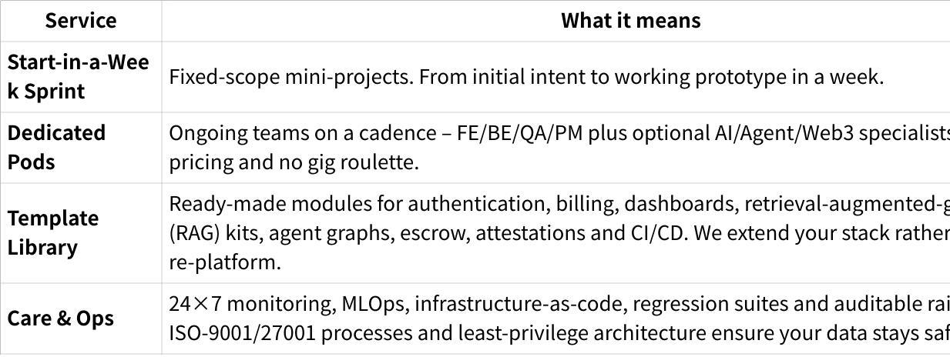
Click the image to view the sheet.

Platform Capabilities
Our market research uncovered several unmet needs: youth engagement (only ~20 % of temple attendees under 30 participate regularly), manual donation management, multilingual requirements and fear of commercialising the Dharma. We designed our white‑label platform to address these pain points:

Custom Branding
Easily adapt the interface to your monastery’s identity. Upload logos, choose colour palettes and typography, and map a custom domain. Pre‑loaded themes evoke Buddhist serenity (e.g., Zen minimalism with lotus motifs or Theravāda gold accents) while remaining neutral across traditions. A step‑by‑step wizard shows real‑time previews and auto‑generates app‑store assets.

Donation Tools
Accept one‑time or recurring dāna via cards, bank transfers or QR codes (for kiosk or smartphone giving). Donors can select preset or custom amounts, receive digital receipts with thank‑you messages and track giving history. Anonymous giving is supported. We frame contributions as acts of generosity, not transactions, with optional sutra quotes and merit dedication verses.

Event & Reminder Calendar
Schedule temple rituals, group meditations or retreats with ease. Views include monthly, weekly or agenda formats. Recurring events (e.g., daily chants or lunar observances) are supported. Automated push or email reminders and RSVP tracking help you plan capacity. Pre‑set templates for important days (Vesak, Uposatha) and integrated chanting timers encourage community reflection.

Compassionate AI Guidance
Our AI agents are configurable. Upload your own knowledge bases and select doctrinal modes such as Zen, Pure Land or Theravāda, with toggles for compassionate or formal response styles. Voice or text queries return curated sutra references and related practices. Guardrails ensure doctrinal integrity; Pali/Chinese script options and daily wisdom prompts foster genuine practice. We are transparent about AI limitations and invite monastic review.

Document & Resource Library
Organise sutras, chants, songs, verses, commentaries and audio/video files in a searchable library. Set access controls (public, members or roles). Offline access and integration with personalised practice paths allow practitioners to take teachings into daily life. Versioning ensures updated translations can be tracked and preserved.

Community Forum (Optional)
If you choose to enable it, a moderated discussion area lets members ask questions, share reflections and form study groups. Topics can be organised by Dharma talk or beginner Q&A. Pre‑built Right Speech guidelines and anonymous posting options support mindful dialogue. Daily digests encourage ongoing participation.

Analytics & Insight (Optional)
An anonymised dashboard shows active users, donation totals and event attendance. Customisable charts help administrators spot trends (e.g., youth engagement) without exposing personal data. Alerts can notify you about low attendance or donation anomalies.

Why Partner with Bodhi Technology Lab
- Trusted by practitioners. Our core team has delivered sacred technology for over a decade. More than 200 engineers, monks and nuns collaborate under ISO‑9001/27001 processes to ensure reliability and integrity.
- Sacred Economics. Our elastic, censorship‑resistant infrastructure scales to zero when idle—so you never pay for unused capacity. Pricing is transparent, with free or low‑cost tiers for small temples and predictable plans for larger communities.
- Consent‑First Privacy. Data is processed locally and remains within its region. Only anonymised, aggregated metrics cross boundaries. User sovereignty is sacred; we never mine or sell data.
- Compassionate Partnership. We co‑create with you. We pilot with councils, provide local training and encourage feedback. Our goal is to cultivate a network of mindful builders where reputation is based on merit, not hype.
- Censorship Resistance. Our decentralised network ensures that Dharma teachings cannot be silenced by any single authority. Verifiable rails and trustless reputation systems anchor truth without exposing private practice.

Sustainable Dharma Infrastructure
Our technology choices are not just technical decisions; they embody our values. We have designed a decentralised, consent‑first infrastructure to support awakening at scale:

Decentralisation Is Compassion
Just as the sangha has no single leader, our network has no single point of control. We leverage a global collective of off‑chain computation nodes to form a censorship‑resistant supercomputer. Each node contributes capacity; no one holds the “master key.” This resilience embodies compassion in code.

Sacred Economics
Elastic compute means the temple is not burdened by idle costs. Capacity bursts for heavy tasks and returns to zero when silent, aligning with the law of cause and effect. You pay only for what you use. No idle tax. Pricing is transparent and predictable.

Elastic Impermanence
Forms arise and pass away. Our infrastructure expands instantly when needed and contracts to nothing when not. Spikes in training or inference can run across thousands of nodes; when there is no demand, everything returns to stillness. There is no waste.

Consent‑First Wisdom
All learning is opt‑in. We support open‑source models and RAG tooling, but AI learns from the sangha only when it is invited to. We never scrape, mine or extract. The AI learns from the community; the community is not harvested for the AI.

Ecological Mindfulness
Tasks are scheduled when green energy is abundant. We prefer idle or existing hardware, ensuring no resource is wasted. Our platform is mindful of the Earth and the future generations that will inherit it.

Immutable Audit Trail
True transparency is possible when every action is recorded in a way that cannot be erased. Our verifiable off‑chain ledgers (DAGs) anchor periodically to a public chain, honouring the law of karma. Private content stays off‑chain, but the integrity of actions is permanently recorded.

Trustless Reputation
Our merit system has two layers: a compute proof that verifies a node did the work, and a merit proof that captures the quality and intent of the act. Every Dharma talk uploaded, chant transcribed or message moderated is attested and becomes part of a reputation that governs access and rewards. Recognition is based on real contribution, not popularity.

Privacy by Design
We process data locally whenever possible and restrict sensitive information to its region. Only anonymised, aggregated metrics leave the locality. There is no data mining; user sovereignty is paramount. Practice cannot coexist with surveillance, so we build systems that respect both consent and confidentiality.

Merit, Not Vanity
This is not social media; it is a digital merit field. Every act of wisdom, compassion or support is attested and rewarded based on true contribution, not popularity. Your reputation grows through service, not through spectacle.

Join the Bodhi Technology Lab
Whether you are a monastery seeking to support your sangha, a meditation centre exploring AI‑guided teachings, or a Buddhist organisation ready to digitise archives, Bodhi Technology Lab offers a compassionate and executional partner. Together we can build tools that help society awaken—fast.

Ready to begin?
- Start a Sprint – scope your idea today and receive a fixed quote within five days.
- Hire a Pod – spin up your team this week and hit production with integrity.
- Deploy – scale your apps on decentralised, verifiable compute with one click.
Let’s co‑create technology that points to freedom.

A Call to the Buddha Family
- To monasteries: Take command of your digital fate. Build with us, on your terms.
- To technologists: Lay down your swords of code in defence of the Dharma.
- To practitioners: Prepare. These are the weapons and shields for the coming Dharma war.
The wheel of Dharma is turning, now in binary. The time to respond is now.

The Fourth Grace Mandala: A Digital Vessel to Close the Kalpa
This is not just software. It is the Mandala of the Fourth Grace, a culmination of all previous mandalas now expressed in electronic form to fulfil the Buddha’s prophecy at the end of the era. It will unite all lineages, all traditions, all awakened ones into a single Body of Light. When its work is done, it will dissolve back into emptiness.

Join the Great Assembly
If you are reading this, you have been called. Step forward and take your place in the restoration of the Dharma. This is the new era of awakening. Do not be left behind.
“When Sun rises, A Great Assembly Will Return.”

